**Change Request -Tour Package**

* 1. Change in Package booking UI -Adding of new TAB named “Payment Request & History”

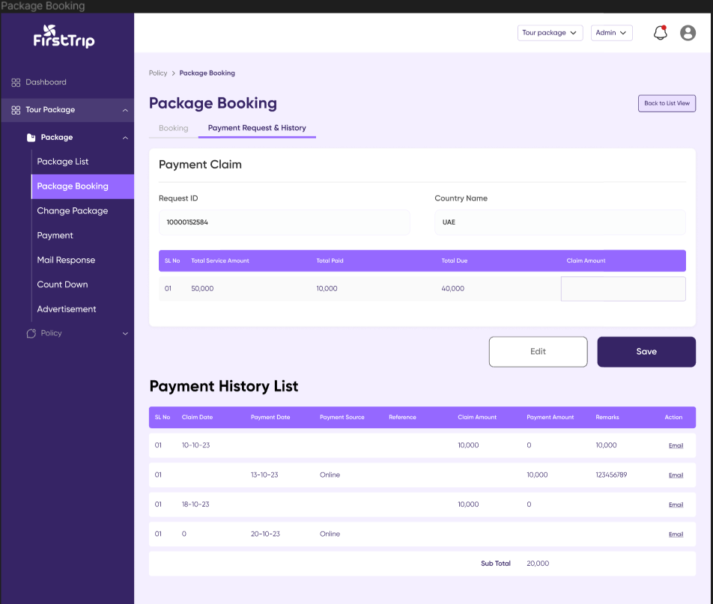

* 1. Under Group fare booking section there will two UI.One is Booking creation UI and another is Payment request UI.These two will separate but related screens will be attached by tab screen.Clicking respective tabs shall switch from Booking creation UI to Payment request UI and vise versa.
  2. There is a constraint to create “payment request”.It can’t be created if there is no booking against that “Request ID”.
  3. Payment Request is a module to claim payment from the requesting customer. In the landing page of Payment request screen there is “payment claim” UI. Through this UI the user shall fill the details to claim payment .
  4. In “payment claim UI” There are following fields through which a payment request entry can be created :

|  |  |  |  |  |
| --- | --- | --- | --- | --- |
| Sl No | Field Name | Is Required | Data Type | Business Rules |
| 1 | Request ID/Booking ID | Yes | read only | 1.Will come from booking entry. |
| 2. | Package Name/Country Name | Yes | read only | 1. Refers the package or country against which the service will be provided. 2. Will come from booking entry against the request Id. |
| 3. | Total Service Amount | Yes | read only | 1.The total amount supposed to be paid by customer end to avail this service. |
| 4. | Total Paid | Yes | read only | 1.The amount paid by customer before the current “payment claim request”. |
| 5. | Total Due | Yes | read only | 1.value of (Total Service Amount-Total Paid) |
| 6. | Claim Amount | Yes | read only | 1.This claim amount is the installment through which customer pay the total service amount. |

i.After clicking the save button a Pop Up UI will appear in the screen.The purpose of this screen is to reassure the request from the user.In this screen the question will appear “Do you really want to save the data?”.Between “Yes” and “no” button clicking yes button will create and entry of payment request in “Payment History” list.And “No” will retain the state of the “Payment claim” UI screen without creating any entry in “Payment History “ list.In clicking “edit “ button the last “payment claim entry” will come in editing mood in this UI.

j . Either a claim request is made or a payment is sent from the customer end an entry for each event will be created in a new list which is “Payment History”.

k.”payment History” list shall hold the below fields :

|  |  |  |
| --- | --- | --- |
| Sl No | Field Name | Business Rules |
| 1 | Claim Date | 1.will come from system after a new “Payment claim” entry is created |
| 2. | Payment Date | 1.will come from system after a new “Payment claim” entry is created |
| 3. | Payment Source | 1. will come from system after a new “Payment” entry is created .This shall happen when a custom does a payment.   2.The value will describe which payment method was used in making a payment e.g:Online,bank. |
| 3. | Reference | 1.will come along with customers payment entry. |
| 4. | Claim Amount | 1.will come from system after a new “Payment claim” entry is created |
| 5. | Payment Amount | 1. will come from system after a new “Payment” entry is created .This shall happen when a custom does a payment. 2. Refers the amount of money paid by the customer. |
| 6. | Remarks | 1.will come according to customers payment entry.This shall refer the method of payment with brief details. |
| 7. | Email | 1.Clicking on email shall redirect to mail setup pop UI.In the mail body preset mail body along with payment claim details will appear.Purpose of this email is to claim a payment amount or confirming the payment done by the customer. |
| 8. | Search | 1.The user will be able to make a table search by the search field. The system filters the searched data based on the search key entered in the search field. |